[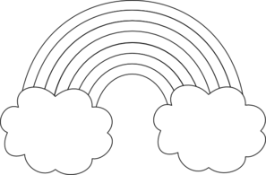](http://www.google.co.uk/url?sa=i&rct=j&q=&esrc=s&frm=1&source=images&cd=&cad=rja&docid=Ui-Q0BXZnUpLbM&tbnid=TkRz0z8cKkIpyM:&ved=0CAUQjRw&url=http%3A%2F%2Fwww.clker.com%2Fclipart-rainbow-with-clouds-outline.html&ei=tfkmUujhPPKa0QXTzID4BA&bvm=bv.51495398,d.ZG4&psig=AFQjCNEvNatP85_y0tJaZopAR9R6JKhlcQ&ust=1378372403456015)