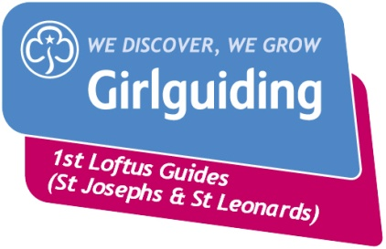
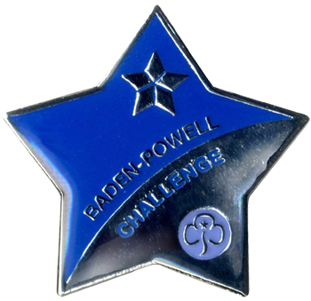
Baden-Powell Challenge Award
Scrapbook

Name:

This is your scrapbook or evidence file for your Baden-Powell Challenge Award. It should show what you have been doing towards each of the challenges.
How to organise your scrapbook
The front page has all the details of what you have done before the challenge started.
Next there should be a planning sheet; this shows the clauses you have worked on.
Each clause should have a copy of the planning sheet and some kind of evidence; this doesn’t have to be your best writing! It might include:
- Photographs showing what you or others did
- Notes and comments from leaders, guides or others
- Flyers, leaflets or tickets – especially if you have been on a visit somewhere
- Your planning notes
- Receipts if you bought items
- Printed out items from the internet
- Finished items like leaflets or posters
What you included will depend on the clause and we can give you help with organising this. Don’t worry about spellings but it is important to do your best! If you have a specific learning difficulty like dyslexia this will be taken into account and you can ask someone else to do the writing for you, but you still need to be actively involved!
Why keep a scrapbook?
At the end of the challenge you will meet with a leader from another unit, usually the district or division commissioner. They will chat to you about what you have done for your award. The scrapbook will give you ideas about what you did, how you did it and what you have learnt from the award. You can also keep this to share with family and friends or use in school to show your skills outside of the classroom.

Pre Award Requirements
Date promise made: __________________________

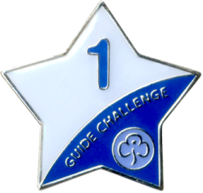
Guide Challenge 1: __________________________

Guide Challenge 2: ___________________________
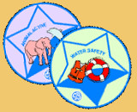
Interest Badge 1: ___________________________

Interest Badge 2: ___________________________

Baden-Powell Award Syllabus
To complete your award you need to select, plan and complete 10 challenges. You must complete at least 1 challenge from each of the zones.
You also need to complete a Baden Powell Challenge Adventure; this will be with girls from other units.
The last stage is share your achievements with another leader, usually the district or division commissioner.
Zone 1: Healthy Lifestyles
Aim: To encourage Guides to lead a healthy lifestyle by promoting physical, emotional and spiritual well-being.
1. Organise and run a Patrol cooking competition. You could provide ingredients and challenge the Patrols to produce dishes in a set time.
2. Set yourself three personal fitness goals and keep a diary for a month to show how you have worked towards them.
3. Run an activity session for your Patrol on an issue which concerns young people today.
4. Help to organise a sports competition with another Patrol or another Guide unit, eg mini-Olympics, fitness trail or team games evening.
5. Complete one of the following badges: Agility, Cook, Healthy Lifestyles, Sports.
6. With your Patrol, plan and carry out a ‘Reflections' session around a chosen theme. You could include a relaxation or meditation aspect or use mime, readings, music, dance or slides.
7. Organise a sponsored fitness event for a good cause.
8. Produce a cookbook of healthy recipes appropriate for Rainbows, Brownies or Guides to use at an event, holiday or camp.

Zone 2: Global Awareness

Aim: To increase awareness of global issues and of the contribution each Guide can make.
1. Find out about the life a child from a country in the global south (the developing world) leads. Share your findings with your Patrol.
2. Organise an activity for your Patrol or unit which will help somebody from a country in the global south (the developing world). Let your local International Adviser know what you are doing.
3. Complete one of the following badges: World Cultures, World Guiding, World Issues.
4. With your Patrol, organise an international evening with games, crafts, food or music and dance.
5. Design a poster on a current global issue and use it to make a presentation to your unit.
6. Use the Internet or your local library to find out about fair trade. Survey what fair trade items are available in your area, for example in your local supermarket. Organise an activity about fair trade with your Patrol.
7. Find out about the Guide Friendship Fund or World Thinking Day Fund and hold a fund-raising evening to support its work.
Zone 3: Discovery

Aim: To challenge Guides with new experiences and adventure.
1. Make a bivouac and spend the night in it. Make your own breakfast the following morning.
2. Start a new hobby or craft, or extend an existing one, and work on it for at least three months. You could try glass painting, learning a musical instrument, football, candle making, rollerblading or stargazing. Find out about your hobby's origins, history and rules. Do a presentation on your hobby for your Patrol in a way that is new to you.
3. Attend a residential event somewhere new to you, eg in a youth hostel or on a narrowboat. Your Baden-Powell Adventure cannot count for this clause.
4. Complete the Outdoor Pursuits, Survival or Community Action badge.
5. Visit a city farm, rescue centre or nature reserve. Discuss with your Patrol why it is important to have these and who benefits from them. What could you do to help?
6. With friends, attend an event such as theatre, ballet, an open air concert or a pop concert. Record your thoughts and impressions and share them with your Young Leader or Leader. Stay safe when you are out and about.
7. Use ICT skills to make a new resource for your unit. What about making a ‘Welcome to Guides' pack, a ‘Guide to camp' or a songbook? You could use photography, video, computers etc.
8. Complete the Guide Camp Permit.
Zone 4: Skills and Relationships

Aim: To develop Guides' self-confidence and self-worth and to improve their interpersonal and life skills.
1. Organise a party for someone outside your unit, such as your local Brownies, your family, or girls not normally involved in guiding; or hold a bring-a-friend party at Guides.
2. Organise a cooperative games evening for your unit, eg parachute games.
3. Help organise a trip with your Patrol to see something of interest to you. Go on the trip and report back to your unit.
4. Find out what there is available for young people in your area. With your unit, organise a discussion to find out about local issues which affect you and what young people can do to assist. Check out your local Connexions centre or speak to a local councillor.
5. Complete one of the following badges: Communicator, Independent Living, Water Safety.
6. Organise an activity based on today's clothing. You could do an analysis of what is suitable for certain activities, what's currently fashionable and what makes you feel good. Present your findings in an interesting way.
7. Raise money to take part in your Baden-Powell Adventure. Could anyone else benefit from your fund-raising?
8. Complete the Active Response or First Aid badge. Hold a First Aid evening for your unit, including incidents and fake wounds, to demonstrate your new skills.

Zone 5: Celebrating Diversity

Aim: To promote active citizenship among Guides, developing their awareness of rights and responsibilities for all.
1. With your Patrol or unit, celebrate a festival from a culture other than your own, eg Diwali, harvest festival, Chinese New Year, Thai Festival of Lights.
2. Organise a disability awareness activity evening or invite someone to your unit to talk about disabilities.
3. Find out about the UN Convention on the Rights of the Child. Organise an activity to share what you have found out.
4. Complete one of these badges: Culture, Discovering faith.
5. Take part in a practical activity to benefit the environment in your local community, such as tree planting, nature conservation or bulb planting.
6. Take part in a WAGGGS initiative. Check out www.wagggsworld.org.
7. What is ‘being you' all about? Make a collage to reflect your culture and lifestyle. Share this with your Leader.
8. Look at guiding in your area and think about units that may not be as fortunate as yours. Think of ways you could offer them assistance. Carry out your ideas and tell your Commissioner how you were able to make a difference.

